Applegate Awareness

Applegate Residential Programs Ltd



APPLEGATE Celebrates 20 years of Service

Inside This Issue:

Self-Care 2

Cultural Competency 3 Health and Safety 4

Q3 2025

Issue 65

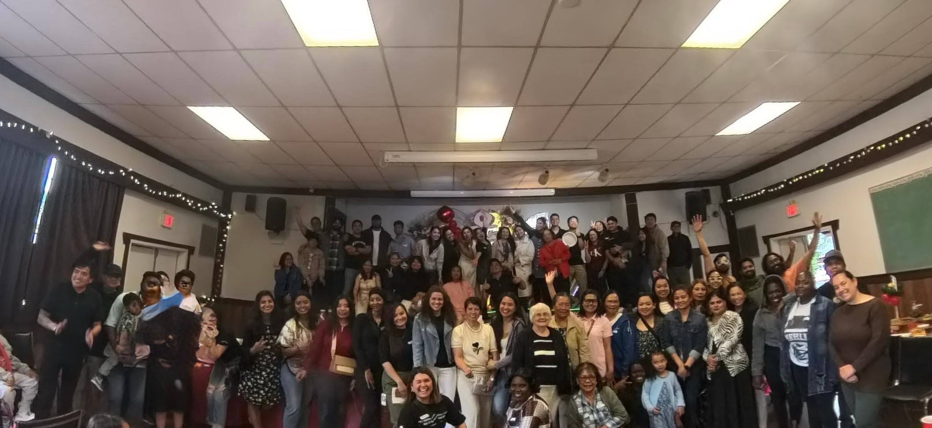

On June 27th 2025, Applegate Residential Programs Ltd, held a Staff Appreciation Event at the Willow Point Lion’s Hall in commemoration of 20 years of service. Since its founding in June

2005, Applegate Residential Programs Ltd has evolved from a heartfelt vision into a thriving network dedicated to supporting children and adults with developmental disabilities.

What began as a heartfelt mission of our Founder CEO/ Rebecca De Aro, has grown into a

trusted organization grounded in the values of inclusion, respect, dignity, and client-centered care.

In photo, are some of the members of the organization celebrating this milestone. Again, we

extend our deepest thanks to every staff member, family, individual, and community partner who has helped shape who we are today. Your passion and commitment have made this work possible

— and meaningful.



[https://www.bing.com/images/shttps:/www.bing.com/images/search?](http://www.bing.com/images/search) view=detailV2&ccid=HHkKtR9w&id=E10E0091EE94A4DD48E6E368C2D638D9161029EF&thid=OIP.HHkKtR9wacIS6TmiiPIZYwHaIY&mediaurl=ht tps%3a%2f%2fst2.depositphotos.com%2f4177785%2f42259%2fv%2f600%2fdepositphotos_422596618-stockillustration-self-care-concept- icons-

First Nations partner to buy B.C. port terminal that moves critical minerals

Two First Nations have formed a joint partnership with a transport company to purchase the Port of Stewart bulk terminal on the Portland Canal that separates British Columbia and Alaska.

The Nisga'a and Tahltan nations and Arrow Transportation Systems said in a statement the deal to buy Stewart Bulk Terminals Ltd., which owns and operates the facility in

Stewart, B.C., is expected to close in the coming months.

Kerry Carlick, president of the Tahltan government, said the deal is "making history" and will drive economic growth and self-determination, while Eva Clayton, president of the Nisga'a Lisims government, said it's a chance for "economic reconciliation."

The three equal partners said the deepsea terminal's primary purpose is transporting critical minerals such as copper concentrate to market from sources including Newmont's Brucejack and Red Chris mines in Nisga'a and Tahltan territories.

The price of the terminal wasn't included in the group's statement, but it said the

province provided a $5-million grant to the Tahltan and Nisga'a nations to support the purchase. The statement quoted B.C. Premier David Eby saying the joint venture furthers reconciliation while creating jobs and "demonstrating how British Columbia will become Canada's new economic engine."

See Full Article:

First Nations partner to buy B.C. port terminal that moves critical minerals | CBC News

Page 4 Health & Safety



Applegate Residential Programs Ltd.

# ADDRESS

710 Applegate Crescent Campbell River, BC V9W 7A2

# PHONE

250-923-8519

# FAX

778-418-1459

# WEBSITE

[www.applegatecare.ca](http://www.applegatecare.ca/)

